Grade 7 Accelerated · Unit 3 · Lesson 1  Product Laws of Exponents  Question Bank 3.01 | Name______________________  Date______________________  Period____________________

Show your work. Circle your final answer.
For questions 1 and 2, write the product as a repeated multiplication expression, then as a single power.
1. 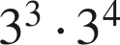

2. 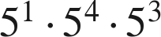

3. Evaluate each power, then multiply. 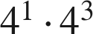

4. Apply the product of powers law, then evaluate the power. 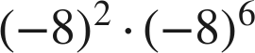

5. Jose says he can evaluate 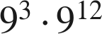 using the product of powers law. Is he correct? Explain, and write the single power.

For questions 6 through 8, use the power of a product law.
6. Write 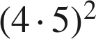 as a repeated multiplication expression, group the repeated factors, then write it in the form 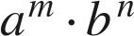.

7. Evaluate inside the parentheses first, then apply the exponent. 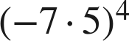

8. Apply the power of a product law, then evaluate. 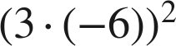

For questions 9 through 11, use the power of a power law or the identity law.
9. Write 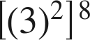 as a single power.

10. Rewrite 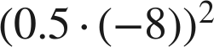 using a law of exponents, name the law, then evaluate.

11. Write each expression using the identity law, then give its value.
a. 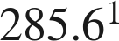

b. 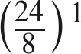

Working backwards.
12. Find the value of that makes each statement true.
a. 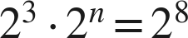

b. 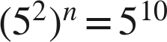

c. 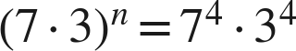

13. Which expression is equivalent to 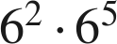 ?
○ A. 
○ B. 
○ C. 
○ D. 

14. Select ALL of the expressions that are equivalent to 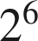.
□ A. 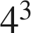
□ B. 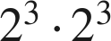
□ C. 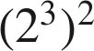
□ D. 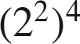
□ E. 
□ F. 

